**2.3ListofUseCase**

**2.3.1<Librarians>OverviewUseCase**

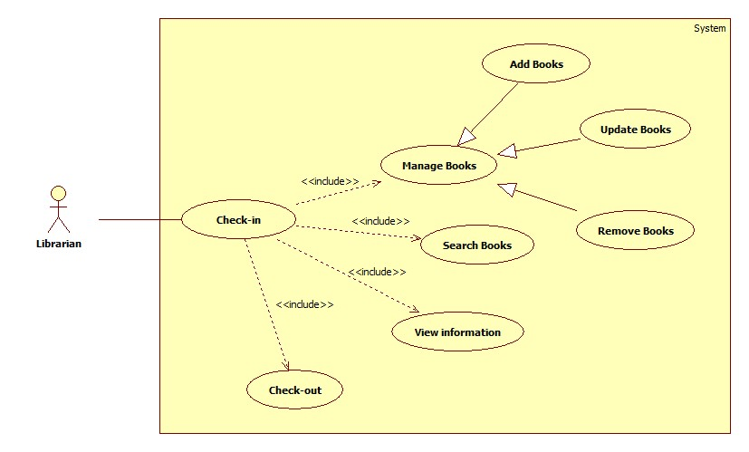

Figure <Librarians> Overview Use Case

**2.3.1.1<Librarians>Staff check-in**

**Use CaseDiagram**

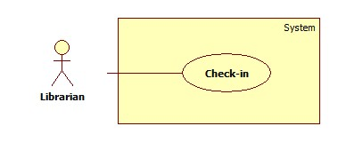

Figure <Librarian> Check-in

**Use Case Specification**

|  |  |  |  |
| --- | --- | --- | --- |
| **USE CASE– LAR01** | | | |
| **Use Case No.** | LAR01 | **Use Case Version** | 2.0 |
| **Use Case Name** | Check-in | | |
| **Author** | AnHDV | | |
| **Date** | 27/02/2015 | **Priority** | High |
| **Actor:**  - Librarian  **Summary:**  - After enter usename/password or scan ID tags, user with role librarian can login in the system.  **Goal:**  - Librarian login successful.  **Triggers:**  - At the login page, user scan the card with the distance is 3cm.  **Preconditions:**  - User must be librarian.  - Login page is display.  - Scanner work right.  **PostConditions:**   * Success: Login is successful. * Fail: Login fail and require user scan the card or input username/password again.   **Main Success Scenario:**   |  |  |  | | --- | --- | --- | | Step | Actor Action | System Response | | 1 | Go to Login page | Login page is display | | 2 | Input username/password or scan ID tags | Validate Login, response user to manage page | |  |  |  |   **Alternative Scenario:**  **N/A**  **Exceptions:**   |  |  |  | | --- | --- | --- | | No | Actor Action | System Response | | 1 | Input wrong username/password | Validate Fail, response user to Login page, post Fail massage | | 2 | Scan wrong ID tags, ID tags without librarian author or broken ID tags. | Validate Fail, response user to Login page, post Fail massage | |  |  |  |   **Relationships:**   * Need to execute the function of librarian object. Such as : Add Books, Update Books, Remove Books…   **Business Rules:**   * N/A | | | |

**2.3.1.2 <Librarians> Manage Books**

**Use CaseDiagram**

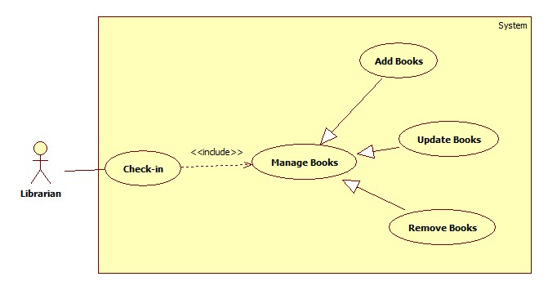

Figure <Librarian> Manage Books

**2.3.1.2.1 <Librarian> Add books**

**Use CaseDiagram**

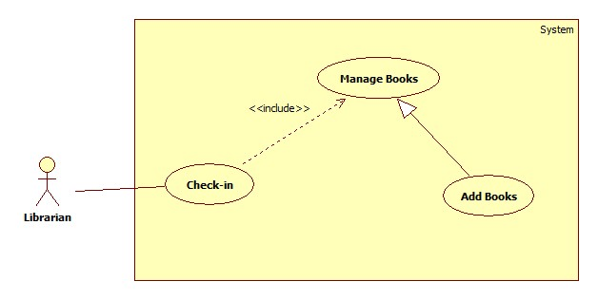

Figure <Librarian> Add Books

**Use Case Specification**

|  |  |  |  |
| --- | --- | --- | --- |
| **USE CASE– LAR02** | | | |
| **Use Case No.** | LAR02 | **Use Case Version** | 2.0 |
| **Use Case Name** | Add New Books | | |
| **Author** | AnHDV | | |
| **Date** | 27/02/2015 | **Priority** | High |
| **Actor:**  - Librarian  **Summary:**  - Librarian can add new books to database.  **Goal:**  - Librarian add a new book successful.  **Triggers:**  - At the screen of librarian works, user click “Add New Book” button.  **Preconditions:**  - User must be login to system with role Librarian.  - Display screen of librarian works.  - User chooses Add Book function.  **Post Conditions:**   * Success: New book will be added to database and the screen will show message “Book has been added successful” * Fail: Book won’t be added to database and the screen will show error message “Cannot add new book. Please check again”.   **Main Success Scenario:**   |  |  |  | | --- | --- | --- | | Step | Actor Action | System Response | | 1 | Go to screen of librarian works | Display screen of librarian works | | 2 | Click “Add New Book” | Display “Add New Book” form | | 3 | User input all information of new Book |  | | 4 | User click “Submit” button | Book will be added to database and the screen will show message “Add New Book successful” |   **Alternative Scenario:**  **N/A**  **Exceptions:**   |  |  |  | | --- | --- | --- | | No | Actor Action | System Response | | 1 | Insert blanks | Response to user the form and show some red highlight error report | | 2 | Insert the same books that exist | Response to librarian work-page the post message report that the same book is exist | |  |  |  |   **Relationships:**   * User must validate at Login function * User must access Manage function pages   **Business Rules:**  - Book to be added didn’t exist in database. | | | |

**2.3.1.2.2 <Librarian> Update Books**

**Use CaseDiagram**

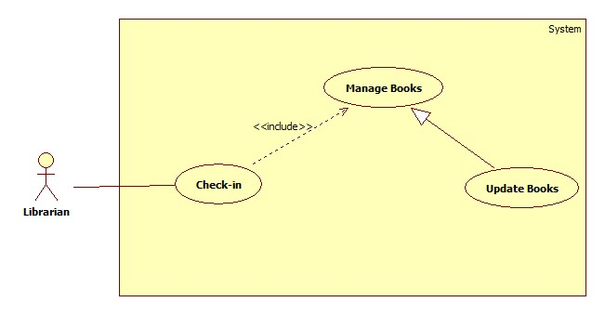

**Figure 2: <Librarian> Update Books**

**Use Case Specification**

|  |  |  |  |
| --- | --- | --- | --- |
| **USE CASE– LAR03** | | | |
| **Use Case No.** | LAR03 | **Use Case Version** | 2.0 |
| **Use Case Name** | Update Books | | |
| **Author** | AnHDV | | |
| **Date** | 27/02/2015 | **Priority** | Normal |
| **Actor:**  - Librarian  **Summary:**  - This use case allows librarian to update information of books.  **Goal:**  - New information of books will be update to database.  **Triggers:**  - At the screen of librarian works, user click “Update Book” button.  **Preconditions:**  - User must be login to system with role Librarian.  - Screen of librarian works is displayed.  - User chooses Update Book function.  **Post Conditions:**   * Success: New information of books will be updated to database and the screen will show message “Book has been updated successful”. * Fail: Information of book won’t be changed and the screen will show message “Update book failed. Please try again”.   **Main Success Scenario:**   |  |  |  | | --- | --- | --- | | Step | Actor Action | System Response | | 1 | Go to screen of librarian works | Display screen of librarian works | | 2 | Click “Update Book” | Display “Update Book” form | | 3 | User input all information of book |  | | 4 | User click “Submit” button | Information will be updated to database and the screen show message “Updated books successful” |   **Alternative Scenario:**  **N/A**  **Exceptions:**   |  |  |  | | --- | --- | --- | | No | Actor Action | System Response | | 1 | Some Books selected does not exist | Send error message that some book does not exist then reload book list page | |  |  |  | |  |  |  |   **Relationships:**   * User must validate at Login function * User must access Manage function pages   **Business Rules:**  - Books updated also reload in database | | | |

**2.3.1.2.3 <Librarian>Remove Books**

**Use CaseDiagram**

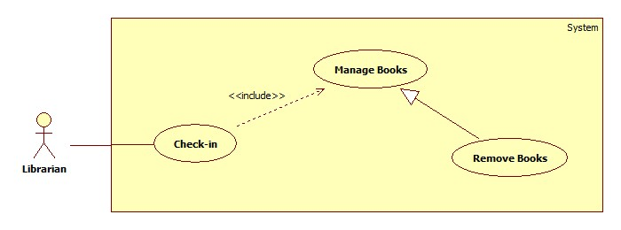

**Figure 2: <Librarian>Remove Books**

**Use Case Specification**

|  |  |  |  |
| --- | --- | --- | --- |
| **USE CASE– LAR04** | | | |
| **Use Case No.** | LAR04 | **Use Case Version** | 2.0 |
| **Use Case Name** | Remove Books | | |
| **Author** | AnHDV | | |
| **Date** | 27/02/2015 | **Priority** | Normal |
| **Actor:**  - Librarian  **Summary:**  - This use case allows librarian to remove books.  **Goal:**  - Book will be removed from database and not exist in system.  **Triggers:**  - At the View List Book, user select books and click “Remove” button.  **Preconditions:**  - User must be login to system with role Librarian.  - List books are displayed.  - User chooses Remove Book function.  **Post Conditions:**   * Success: Books will be removed from the database and the screen will show message “Removed book successful” * Fail: Books cannot remove and the screen will show error message “Removed fail. Please check again”.   **Main Success Scenario:**   |  |  |  | | --- | --- | --- | | Step | Actor Action | System Response | | 1 | Go to View List Books | Show list books | | 2 | User select books want to remove book |  | | 3 | User click “Remove Book” button | Book will be removed from database and show message “Removed success” |   **Alternative Scenario:**  **N/A**  **Exceptions:**   |  |  |  | | --- | --- | --- | | No | Actor Action | System Response | | 1 | Some Books selected does not exist | Send error message that some book does not exist then reload book list page | |  |  |  | |  |  |  |   **Relationships:**   * User must validate at Check-in page * User must access to manage function pages * User must load book list   **Business Rules:**  - Books remove also delete in database | | | |